ELEVATOR PITCH SPEECH

Hello everyone!

I’m thrilled to share my game idea: Stranded in the Jungle. It’s a text-based, *choose your own adventure* game where players navigate the challenges of being lost in the jungle as night falls. The storyline is driven by player decisions, like building a shelter, exploring for food, or attempting to signal for rescue, each with its own consequences, such as survival, discovery, or danger. The game concludes with either being rescued or starting over, depending on the player's choices.

Technically, I’ll use Python and Pygame for implementing graphics and sound effects to enhance immersion, like jungle ambiance and alerting sounds when danger strikes. The main challenge for me will be learning to design smooth transitions between decision nodes and incorporating interactive menus while keeping the game intuitive and engaging.

I’ve outlined the gameplay flow and sketched out an intro screen along with the required sprite elements, such as jungle backdrops and action indicators like fires and rivers. My goal is to deliver a simple, working prototype that balances fun and functionality.

I’d love your feedback, especially on making the branching storylines more engaging or ideas to improve player immersion.

Thank you so much!

### GAME DESIGN DOCUMENT: Stranded in the Jungle

#### Overview - Setting

You are stranded in a dense jungle as night approaches. Survival is your goal. With the options to build a shelter, search for food, or explore the surrounding wilderness, every decision impacts your chances of survival. Navigate through obstacles like building shelters and wild animals. Your ultimate objective is to signal for rescue and escape the jungle.

#### Game Diagram:

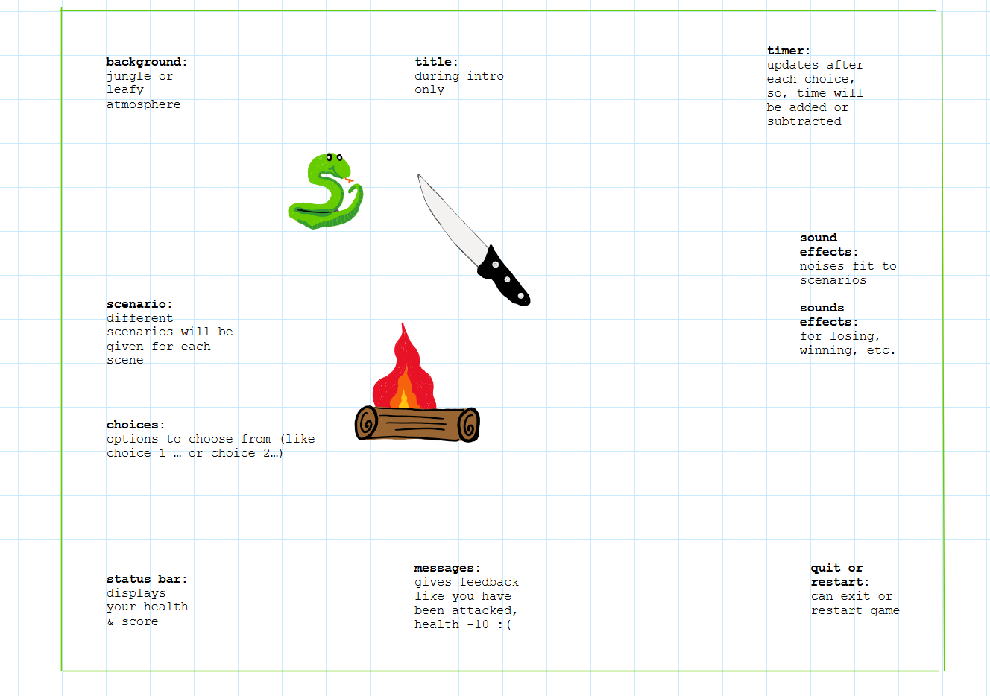

### **Title and Timer Section (Top)**

* **Title:** "Stranded in the Jungle!"
* **Timer:** Displays at the top of the screen

### **Main Character (Center)**

* The stranded explorer is represented through text-based choices and scenario descriptions.
* Example:
  + "You are stranded in the jungle, equipped with only a backpack and a machete. What will you do next?"
* Arrows indicating movement options that are represented as numbered choices
* Example:
  + 1. Move Left
  + 2. Move Right
  + 3. Move Forward
  + 4. Stay Here

### **Jungle Background**

* Description of the dense jungle serves as the immersive setting in text form.
* The background dynamically changes based on the scenario
* Examples:
  + Crossing a river: "The rushing sound of water fills your ears as you approach the riverbank."
  + Encountering animals: "A jaguar crouches low in the underbrush, watching you with unblinking eyes.”

### **Obstacles (Scattered)**

* Obstacles described through text and their consequences highlighted
* Examples:
  + "You spot a snake slithering toward you. It bites you! Health decreases by 20."
  + "A fallen tree blocks your path. You must climb over it or find another way."
* Labels for obstacles
* Examples:
  + "Avoid the snake! Lose points if bitten."
  + "Cross the river to reach safety."

### **Game Objectives (Side)**

* Objectives communicated in the side HUD or through scenario prompts
* Examples:
  + "Collect items to survive: food, tools, and maps."
  + "Navigate through the jungle without losing health."
  + "Score increases when you find survival gear or reach a safe zone."

### **User Interface Elements (Bottom)**

* **Reset Button:** A keypress (3) restarts the game.
* **HUD Components:**
  + **Score Counter:** Tracks survival points. Example: SCORE: 120.
  + **Health Bar:** Text-based representation of health (e.g., HEALTH: 80/100).
* Examples:
  + "Warning: Wild animal nearby!"
  + "You found food! Health restored."
  + "You have built a shelter! Health will no longer decrease overnight."

### **Sound and Interactivity**

* **Ambient Jungle Sounds:** Adds immersion (optional for text-based). Examples:
  + Bird chirping, insects buzzing, rustling leaves.
* **Event Sounds:**
  + Snake hiss for a bite encounter.
  + Splashing sound when crossing the river.
* **Victory Music:** Plays when rescued.
* **Failure Sounds:** Ominous tone for death or game over.

### Game States

intro → menu → gameplay → end

#### **Intro**

* **Game Title:** "Stranded in the Jungle."
* **Brief Instructions:**
  + Example:
  + "You are stranded in the jungle. Make decisions wisely to survive. Type the number of your choice to proceed."
* **Start Game Button:** Player types 1 to start.

#### **Menu**

* Presents key decision options:
* Examples:
  + 1. Build a Shelter → Leads to the shelter scenario.
  + 2. Explore the Jungle → Leads to exploration paths.

#### **Gameplay**

* Title is hidden during gameplay.
* Story-driven text with branching choices determines progress.
* Examples of branching scenarios
* Examples:
  + Build a fire: "You gather sticks and light a fire. The warmth improves your health."
  + Encounter wild animals: "A snake bites you! Health decreases by 20 points."

#### **End States**

* **Success:** "You signal a rescue team and are saved. Congratulations!"
* **Failure:**
  + Poisoned: "The snake's venom takes its toll. You succumb to the jungle."
  + Drowned: "The river's current is too strong. You are swept away."
* Restart or quit options are offered at the end.

### Sprites (Text Descriptions)

#### **Player**

* The player character is described in the scenario text.
* Status is reflected in text feedback
* Example:
  + "You are hungry."
  + "You have been poisoned!"

#### **Shelter**

* A successful shelter build is described: "You construct a simple lean-to with branches and leaves."

#### **Food**

* Fruits or hunted food are represented through text descriptions.
* Example:
  + "You find edible berries and regain 10 health."

#### **Fire**

* Fire is represented textually: "The fire crackles and keeps the wild animals away."

#### **River**

* River encounters are narrated: "The river's current is fast. You need a rope to cross safely."

### UI Components

#### **Title**

* Intro screen displays the title: "Stranded in the Jungle."

#### **LblMessage**

* Dynamic messages communicate actions:
  + "You found food. Health restored!"
  + "You were bitten by a snake. Health decreases by 20."

#### **Buttons**

* Key inputs for navigation:
  + 1. Start Game
  + 2. Make a Decision
  + 3. Restart
  + 4. Quit

#### **LblOutcome**

* Displays success or failure message at the end of the game.

### Sound Effects

#### **Ambient Jungle Sounds**

* Birds, insects, and rustling leaves create immersion (optional).

#### **Event Sounds**

* Snake hiss for danger, fire crackling for warmth, and water splashing for river crossing.

#### **Victory Music**

* Short celebratory tune when the player is rescued.

### Milestones

* **Week 1:**
  + Create the basic text interface and branching menu logic
* **Week 2:** 
  + Add a timer, health system, score counter, and end states.
* **Week 3:** 
  + Develop more detailed scenarios (e.g., shelter building, river crossing).
* **Week 4:** 
  + Playtesting and polishing transitions and story text flow.

### Game Tuning Parameters

1. **Health Loss Rates**
   * Amount of health lost during specific encounters:
   * Examples:
   * Snake bite: Default -20 health.
   * Hunger penalty: Default -10 health every 15 decisions if no food is found.
2. **Difficulty Levels**
   * Introduce adjustable difficulty modes
   * Examples:
   * Easy: Fewer obstacles, more food opportunities, slower timer.
   * Hard: More frequent animal encounters, faster timer, fewer resources.
3. **Random Events Frequency**
   * Adjust how often random obstacles appear (e.g., wild animals or natural barriers).

### Stretch Goals

1. **Time-Based Survival Mechanics**
   * Introduce hunger and fatigue meters:
   * Example:
   * Hunger: Gradual health loss without finding food
2. **Expanded Survival Challenges**
   * Add additional survival mechanics
   * Examples:
   * Crafting: Combine tools (e.g., a rope and stick to make a spear).
   * Hunting: Introduce scenarios where players can trap animals for food.
3. **New Biomes or Scenarios**
   * Add alternate settings beyond the jungle:
   * Examples:
   * Desert: Dehydration and sandstorms.
   * Arctic: Freezing temperatures and ice hazards.